

Sri Lanka Institute of Information Technology

**Management System for Orocare Toothpaste Company**

**Project Report**

Information Technology Project 2018

Project ID: ITP-2018-MLB-G1-08

Submitted by:

1. 1. IT17042352 – (P.P.G.S.H.A.Guruge)
2. 2. IT17052498 – (Jayawardena J.K.S.L)
3. 3. IT17051644 – (Illandara T.S)
4. 4. IT17048088 – (Nirathanka O.R.M)
5. 5. IT17024464 – (Perera D.J.R)
6. 6. IT16037816 – (Weerasooriya M.N.H)
7. 7. IT16003606 – (Serasinghe N.H)
8. 8. IT17028288 – (B.R.I.S Gunatileka)

Submitted to:

(Supervisor’s signature)

…………………………..

**Ms. Uthpala Samarakoon**

-2018

**Abstract**

The Orocare Toothpaste company has now been gradually expanded and the company finds difficulty in handling company’s work manually. One of the major problems faced by the company is that the client, the owner of the company receives sales details at the end of the week by his sales representatives. The client get updates of his sales occasionally.

In order to succeed with their expansion, Orocare is in a need for automated system and is looking for IT services firm

The solution proposed by us as IT students is to develop a system that fulfills main aspects of the company’s management.

The proposed system management systems ensures that the company’s details are managed, manipulated automatically. Specially the system will keep the staff frequently updated.

**Acknowledgement**

The project group would like to take this opportunity to gratefully acknowledge the help and guidance from Dr.Krishan Perera, CEO of Orocare Toothpaste.

**Declaration**

We declare that the this project report or part of it was not a copy of a document done by any organization, university any other institute or a previous student project group at SLIIT and was not copied from the Internet or other sources.

Project Details

|  |  |
| --- | --- |
| Project Title | Management System for Orocare Toothpaste Company |
| Project ID | ITP-2018-MLB-G1-08 |

Group Members

|  |  |  |
| --- | --- | --- |
| **Reg. No** | **Name** | **Signature** |
| IT17042352 | P.P.G.S.H.A.Guruge |  |
| IT17052498 | Jayawardena J.K.S.L |  |
| IT17048088 | Nirathanka O.R.M |  |
| IT17051644 | Illandara T.S |  |
| IT17024464 | Perera D.J.R |  |
| IT16037816 | Weerasooriya M.N.H |  |
| IT16003606 | Serasinghe N.H |  |
| IT17028288 | Gunatileka B.R.I.S |  |

**Table of Contents**

**Abstract i**

**Acknowledgement ii**

**Declaration iii**

**Table of Contents iv**

**List of Figures v**

**List of Tables v**i

**List of Acronyms and Abbreviations v**ii

**1.** **Introduction** [**1**](https://docs.google.com/document/d/1OMebh78TqHHQS4rqijtGB7pHNIcYk5hL2cNLPWColXo/edit#heading=h.2bn6wsx)

1.1 Problem Statement

1.2 Product Scope

1.3 Project Report Structure

**2.** **Methodology 2**

2.1 Requirements and Analysis

2.2 Design

2.3 Implementation

2.4 Testing

**3.** **Evaluation 3**

3.1 Assessment of the Project results

3.2 Lessons Learned

3.3 Future Work

**4.** **Conclusion 4**

**5.** **References** [**5**](https://docs.google.com/document/d/1OMebh78TqHHQS4rqijtGB7pHNIcYk5hL2cNLPWColXo/edit#heading=h.3as4poj)

**Appendix A: Design Diagrams** [**6**](https://docs.google.com/document/d/1OMebh78TqHHQS4rqijtGB7pHNIcYk5hL2cNLPWColXo/edit#heading=h.1pxezwc)

**Appendix B: Test Results** [**7**](https://docs.google.com/document/d/1OMebh78TqHHQS4rqijtGB7pHNIcYk5hL2cNLPWColXo/edit#heading=h.49x2ik5)

**Appendix C: Selected Code Listings** [**8**](https://docs.google.com/document/d/1OMebh78TqHHQS4rqijtGB7pHNIcYk5hL2cNLPWColXo/edit#heading=h.2p2csry)

**List of Figures**

*<Insert a list of figures; mention the number name and the page number of each figure>*

|  |  |  |
| --- | --- | --- |
| Number | Name | Page |
|  |  |  |
|  |  |  |
|  |  |  |
|  |  |  |

**List of Tables**

*<Insert a list of tables; mention the number name and the page number of each table>*

|  |  |  |
| --- | --- | --- |
| Number | Name | Page |
|  |  |  |
|  |  |  |
|  |  |  |
|  |  |  |
|  |  |  |

**List of Acronyms and Abbreviations**

*<Insert a list of acronyms and abbreviations; describe the specific meaning of those terms in your project>*

# Introduction

## Problem Statement

Orocare is a Toothpaste Company which has started recently. Since the company has started in small scale, every part of the company’s business is managed manually. Now with the increase in business opportunities the business has been expanded in all areas such as sales,products,customer information etc which has made the day to day work more complex than before.

With the increase in complexity and work load the owner and the employee’s have started to face major problems such as

1.Improper recording of transactions.

2.Missing certain records.

3.Stock information not been updated real time and notified leading to empty stocks’s.

4.Lack of resources to record all the data.

These are some of the problems faced by the company.If the business is carried out in the current way these problems will continue to occur.Therefore they have realized the importance of maintaining a management system for a more easier and convenient way of carrying out the business.

## Product Scope

The application that has been developed is used to automate every part of the company that is done manually currently.Therefore we have categorized the major functions as,

* Stock Management
* Customer Management
* Product Management
* Finance Management
* Utility Management
* Employee Management
* Sales Management
* Employee Salary Management
* User management
* Supplier Information Management
* Supplier Order Management

## Project Report Structure

Rest of the chapters are divided into 3 major categories,

1.Methodology

2.Evaluation

3.Conclusion

Methodology is further divided into 4 main parts,

1.Requirements and Analysis - Includes use case scenarios related to requirements for each function.

2.Design - Design includes high-level overview system diagram, activity diagrams, class diagrams, fully Integrated class diagram, ER diagram of the system.

3.Implementation - Detailed descriptions of individual functions and the overall background of the implementation.

4.Testing - Testing includes the methodology of testing with test results.

Evaluation is further divided into 3 parts,

1.Assessment of the project results - Analysis of data,objectives and deficiencies in the final product.

2.Lessons Learned - Lessons learned during the process of making.

3. Future work - suggestions for future works.

Conclusion

Summary of the whole project.

# Methodology

## Requirements and Analysis

Requirement 1 - Record details of the orders given by the customer in a database system.

Use case scenario -

|  |  |
| --- | --- |
| Use case Id | 1 |
| Title | Inserting order |
| Primary Actor | Privileged user |
| Description | Inserting an order taken by a customer to the database. |
| pre-conditions | Fully functional java application |
| post-conditions |  |
| Main-scenario | 1.Select order type (external or internal)  2.Select customer name,id from customer table.  3.Enter quantity,discount to the relevant text fields.  4.Select product and location from the stock/product table.  5.Check total by clicking the check total button.  6.Total displayed in the total box.  7.Choose date from the date picker box.  8.Click the add button.  9.Inserted successfully message displayed. |
| extension | 6a.Validation error displayed.  9a.Validation error displayed. |

Table 1.4.1

Requirement 2 - Recording of stock item details in a system database.

use case scenario -

|  |  |
| --- | --- |
| **Topic** | Add Stock Item |
| **Primary Actor** | Privileged User |
| **Preconditions** | User should be initially logged into the system.  User must have the Stock Managing privilege. |
| **Main Success Scenario** | 1.User clicks the button and go to Stock Management UI.  2.User selects a Product Name.  3.User selects and fill other relevant text fields.  4.Click insert button.  5.Pass the validation process.  6.Add stock details to DB. |
| **Extensions** | 5a. User failed to pass the validation process.  5a1. Show error message.  5a2. Ask user to re-enter details.  5a3. Clear previously filled details.    6a. System failed to add details into DB.  6a1. System shows an error message.  6a2. System ask the user to retry. |

Table 1.4.2

Requirement 3 - Recording of Employee salary details in a system database.

use case scenario -

|  |  |  |
| --- | --- | --- |
| **Use case ID** | OC - 001 | |
| **Name** | Add employee salary details | |
| **Summary** | Administrator input details, calculate salary and add to the system | |
| **Primary Actor(s)** | Administrator | |
| **Pre-condition** | User should have logged successfully in to the system | |
| **Post-condition** | Salary details will be added successfully | |
| **Main Scenario** | **Step** | **Action** |
|  | 1 | User login to “Salary” system via dashboard |
|  | 2 | User selects a valid employee by selecting an available NIC number |
|  | 3 | User inputs for Allowance |
|  | 4 | User inputs for Leaves |
|  | 5 | User inputs for Deductions |
|  | 6 | User inputs for EPF & ETF rates |
|  | 7 | User inputs for Net Salary |
|  | 8 | User selects the Month |
|  | 9 | User presses “Calculate Salary” button |
|  | 10 | System generates EPF, ETF and Calculated salary |
|  | 11 | User presses “Add” button |
|  | 12 | Salary details are added to the system database |
|  | 13 | User logout from the system |
| **Extensions** | **Step** | **Branching Action** |
|  | 9a | If invalid data was added, display proper error messages |
|  | 11a | If invalid data was added or salary calculation wasn’t done,  Display proper error messages /ask to press “Calculate Salary” button |

Requirement 4 - Recording of Employee Registration details in a system database.

use case scenario -

|  |  |  |
| --- | --- | --- |
| **Number** | 0016 | |
| **Name** | Employee Registration. | |
| **Summary** | Administrator registering employee details for the company. | |
| **Priority** | 1 | |
| **Pre-conditions** | User should log into the system successfully. | |
| **Post-conditions** | Employee will be registered or rejected. | |
| **Primary Actor(s)** | Administrator | |
| **Trigger** | Employee applying for the registration. | |
| **Main Scenario** | **Step** | **Action** |
|  |  | Registration form published in the  Employee management system. |
|  |  | Input first name. |
|  |  | Input middle name. |
|  |  | Input last name. |
|  |  | Select the gender. |
|  |  | Input the address. |
|  |  | Select the date of birth. |
|  |  | Input the mobile number. |
|  |  | Input the position. |
|  |  | Input the NIC. |
|  |  | Input the email address. |
|  |  | Select the user privileges. |
|  |  | Press “Add” button & details will be added to the system. |
|  |  | After that select that row & press “Activate User” button, only then the employee status will be changed into active. |
|  |  | Administrator logout from the system. |
| **Extensions** | **Step** | **Action** |
|  | 13a | If the registration details invalid,  the system prompt error messages &  re-enter the valid details. |

Requirement 5 - Recording of Customer details in a system database.

use case scenario -

|  |  |  |
| --- | --- | --- |
| **Use case ID** | OC - 085 | |
| **Name** | Add customer details | |
| **Summary** | Receptionist input customer’s details into the system | |
| **Primary Actor(s)** | Receptionist | |
| **Pre-condition** | User should have logged successfully in to the system | |
| **Post-condition** | Customer details will be added successfully | |
| **Main Scenario** | **Step** | **Action** |
|  | 1 | User login to “Customer Management” system via dashboard |
|  | 2 | User inputs for Customer’s Name |
|  | 3 | User inputs for Customer’s Address |
|  | 4 | User inputs for Customer’s Contact Number |
|  | 5 | User inputs for Customer’s Email Address |
|  | 6 | User inputs for Customer’s Type |
|  | 7 | User presses “Add Button” |
|  | 8 | Customer details are added to the system database |
|  | 9 | User logout from the system |
| **Extensions** | **Step** | **Branching Action** |
|  | 7a | If invalid data was added, display proper error messages |

## Design

**System Overview**

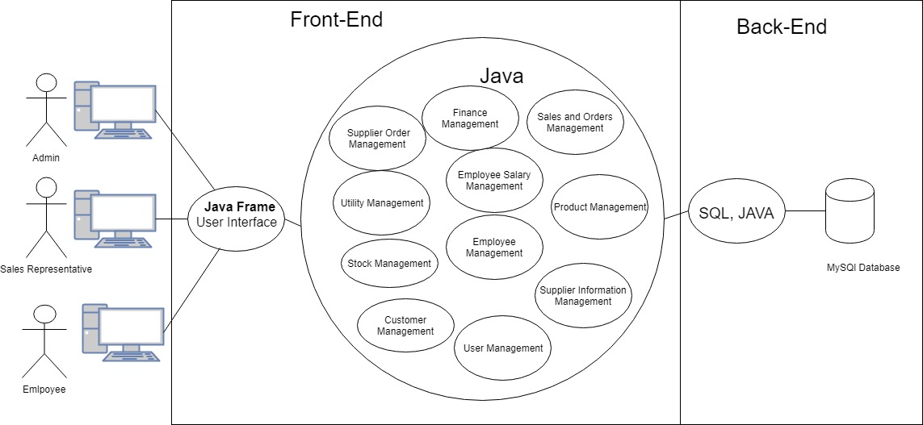

High level system overview diagram

In the above diagram an overview of the system is show in simplest form.

All the users in the system deals with the system via the User Interface which is designed using Java Frames, and all the core modules of the system are connected to the database.

**Order Management**

**Class diagram** -

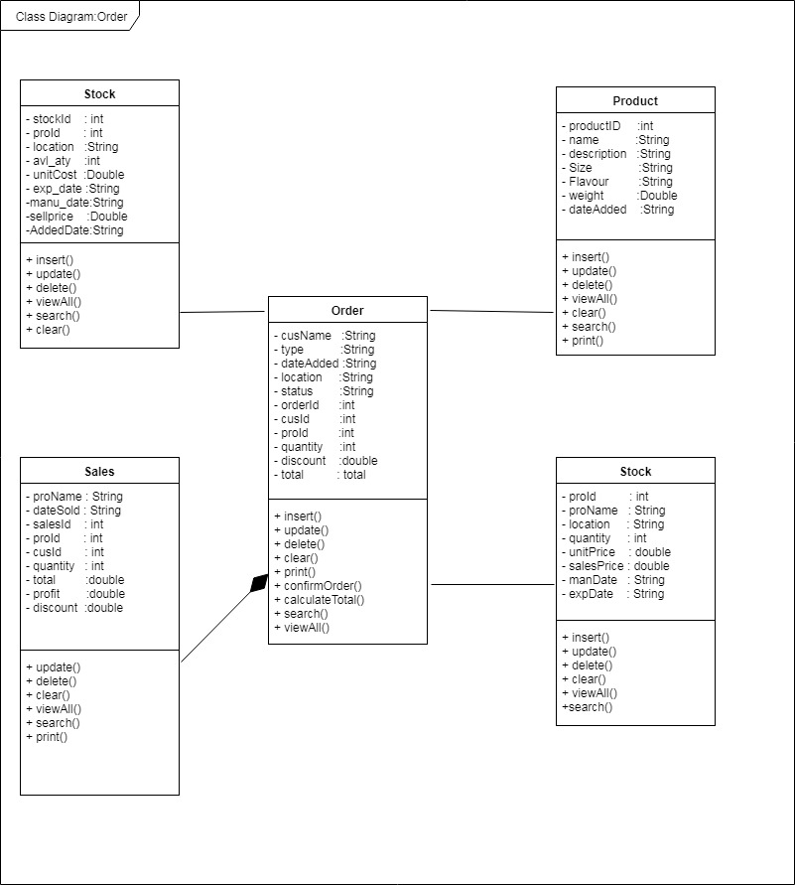

**Activity Diagram -**

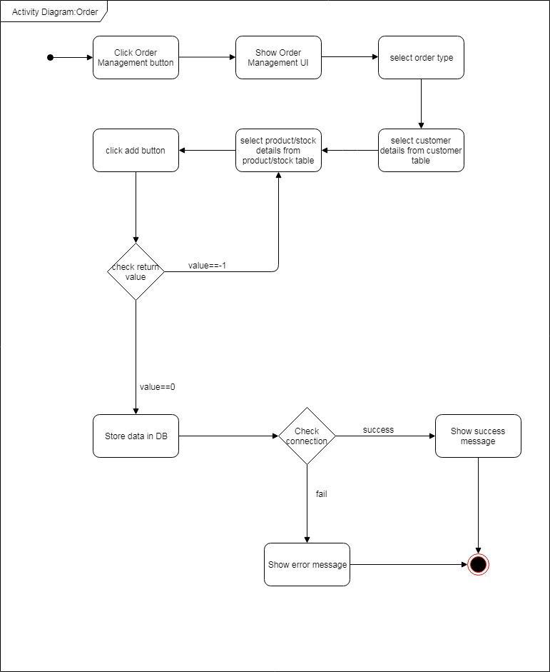

**Stock Management**

**Class diagram -** 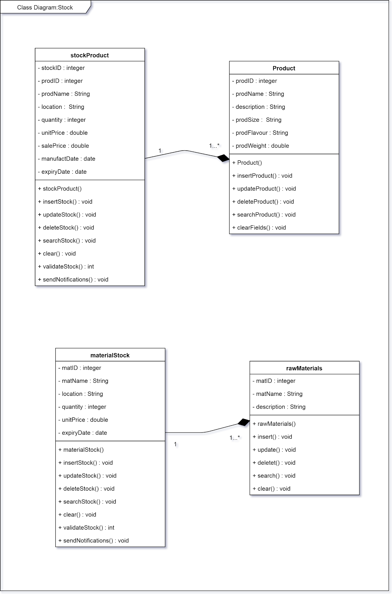

**Activity diagram -**

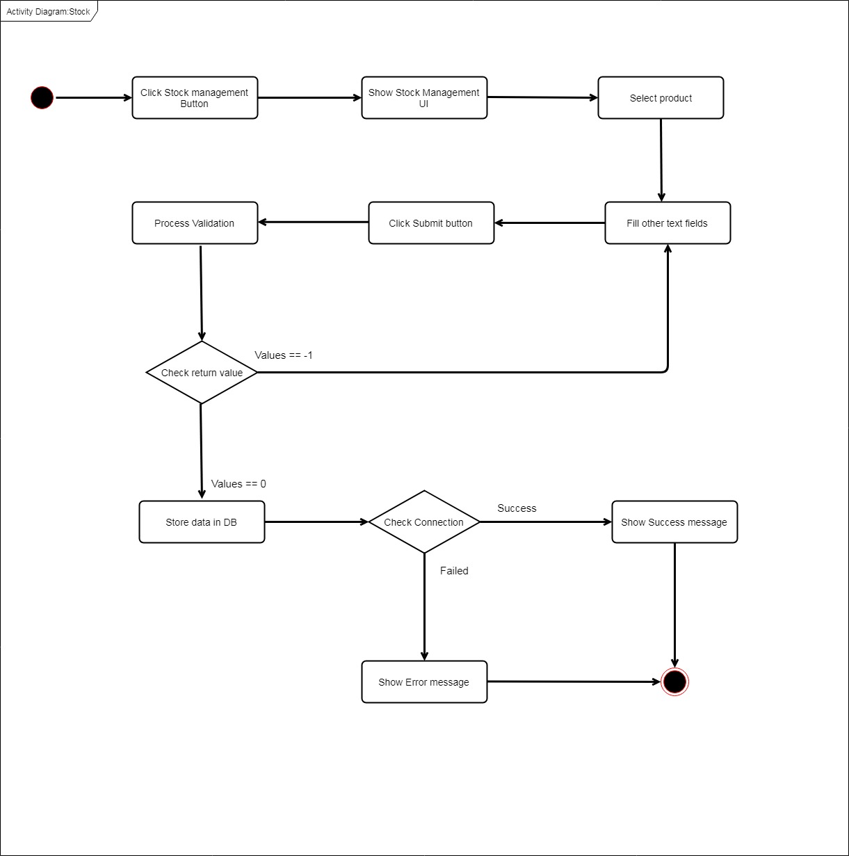

**Employee Salary Management**

**Class diagram -**

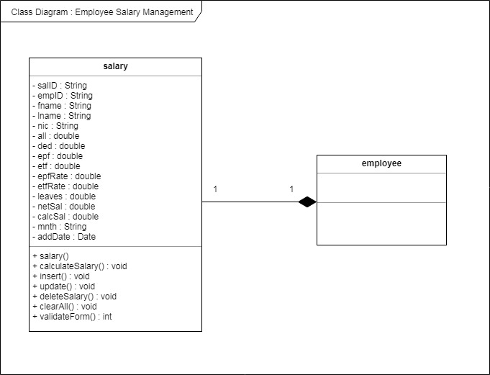

**Activity Diagram -**

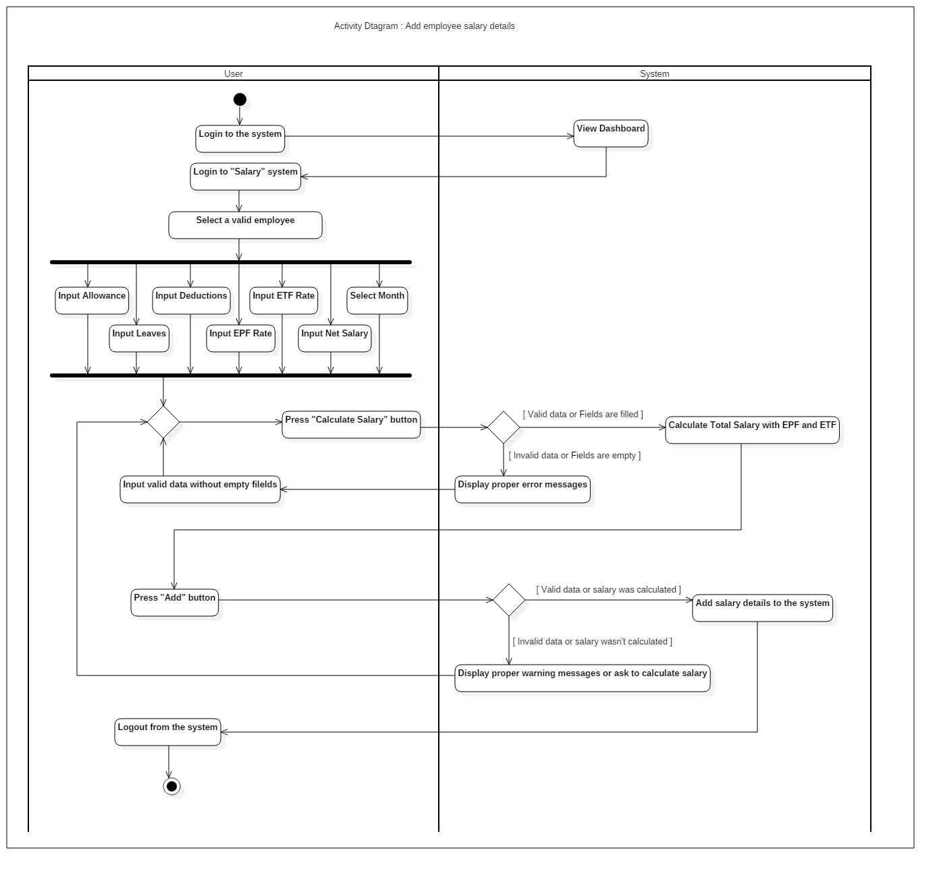

**Employee Management**

**Class diagram -**

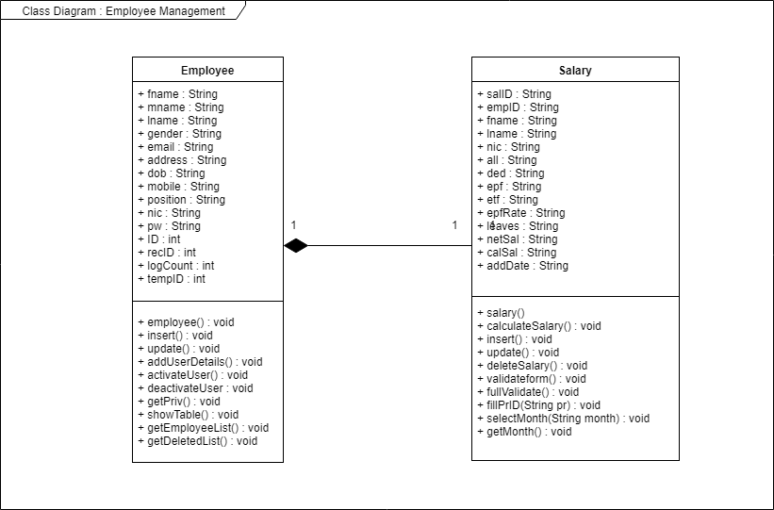

**Activity diagram -**

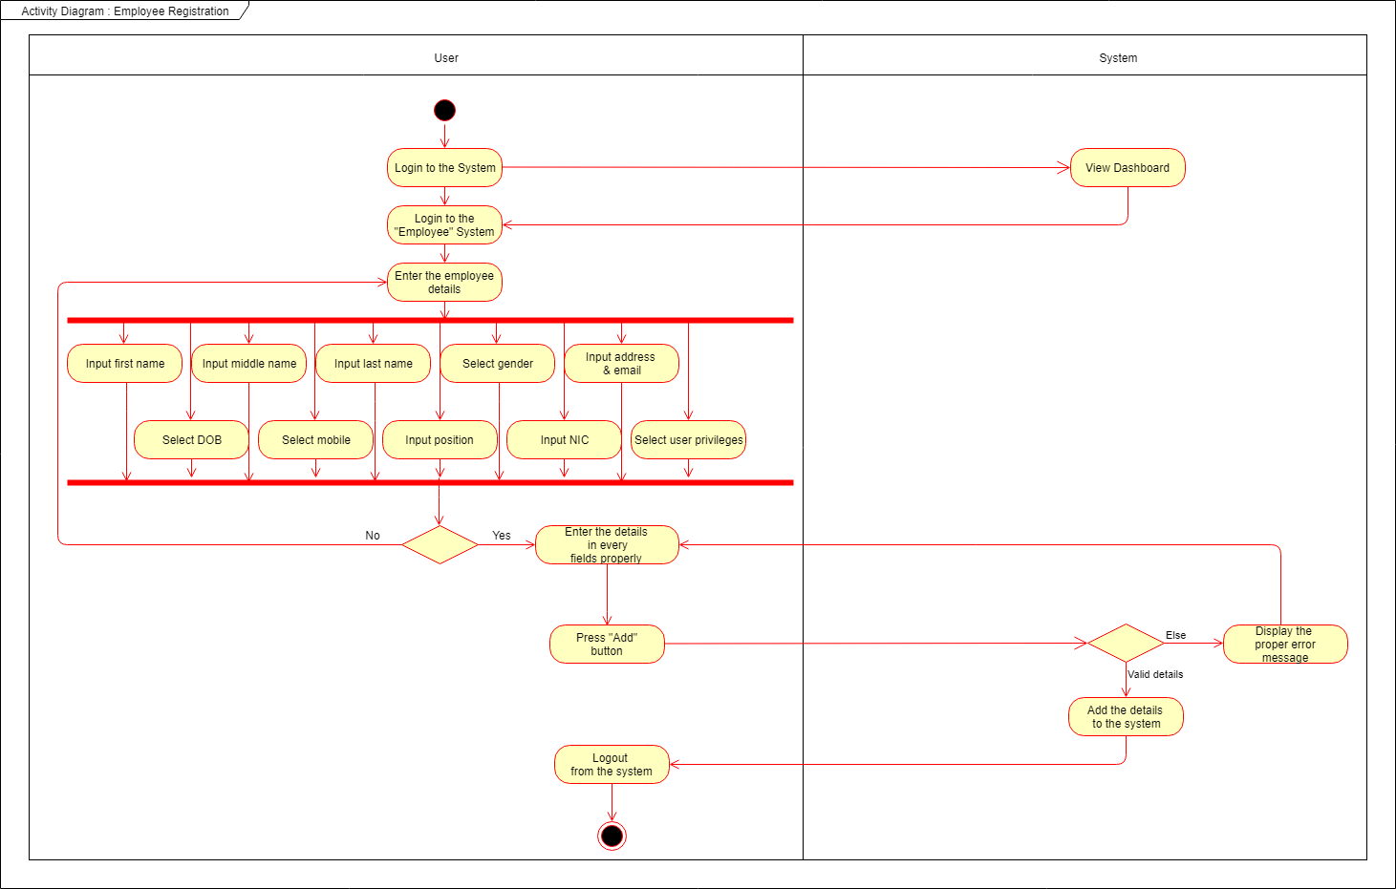

**Customer Management**

**Class diagram -**

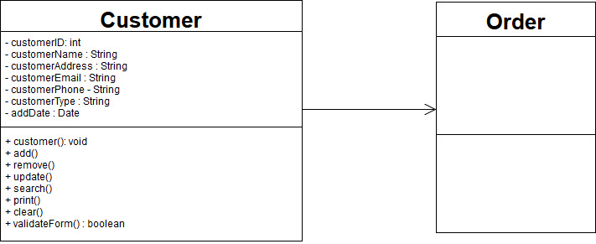

**Activity Diagram -**

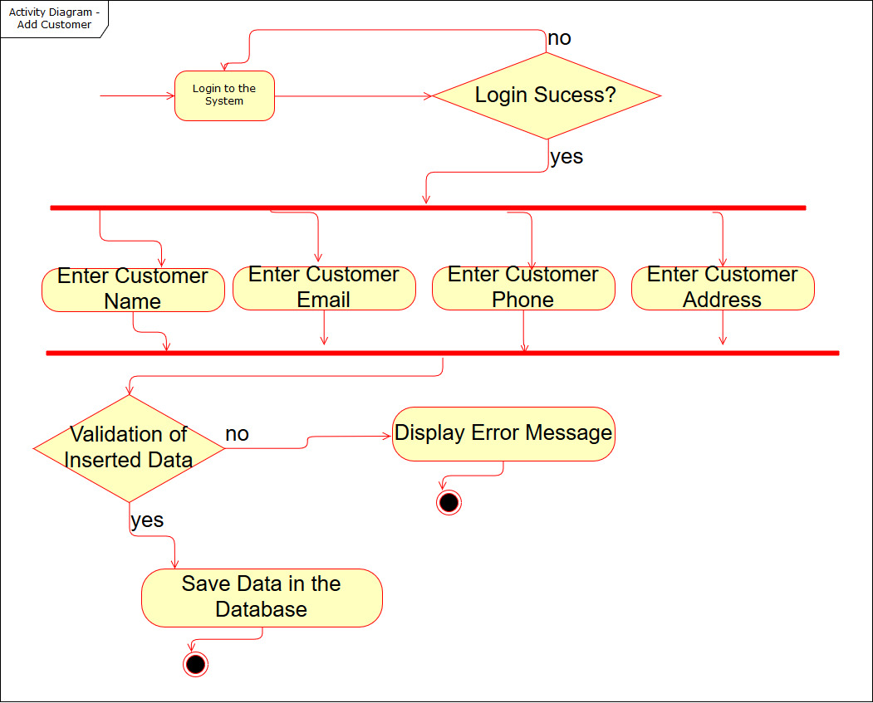

**Fully Integrated ER diagram**

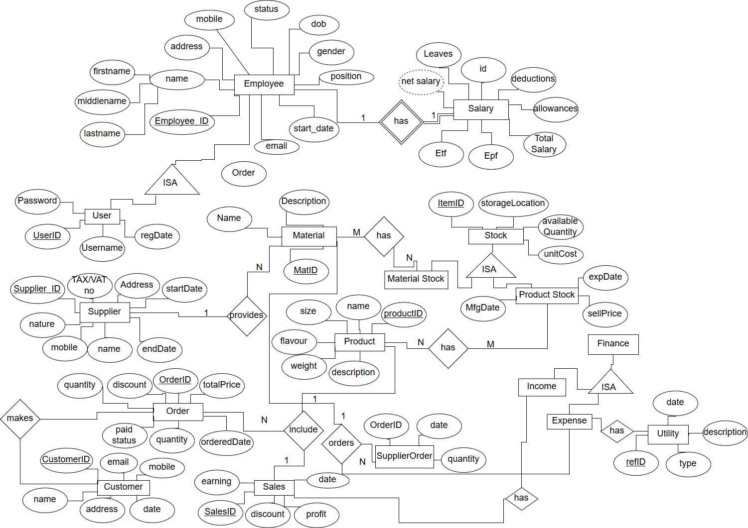

**Fully Integrated class diagram**

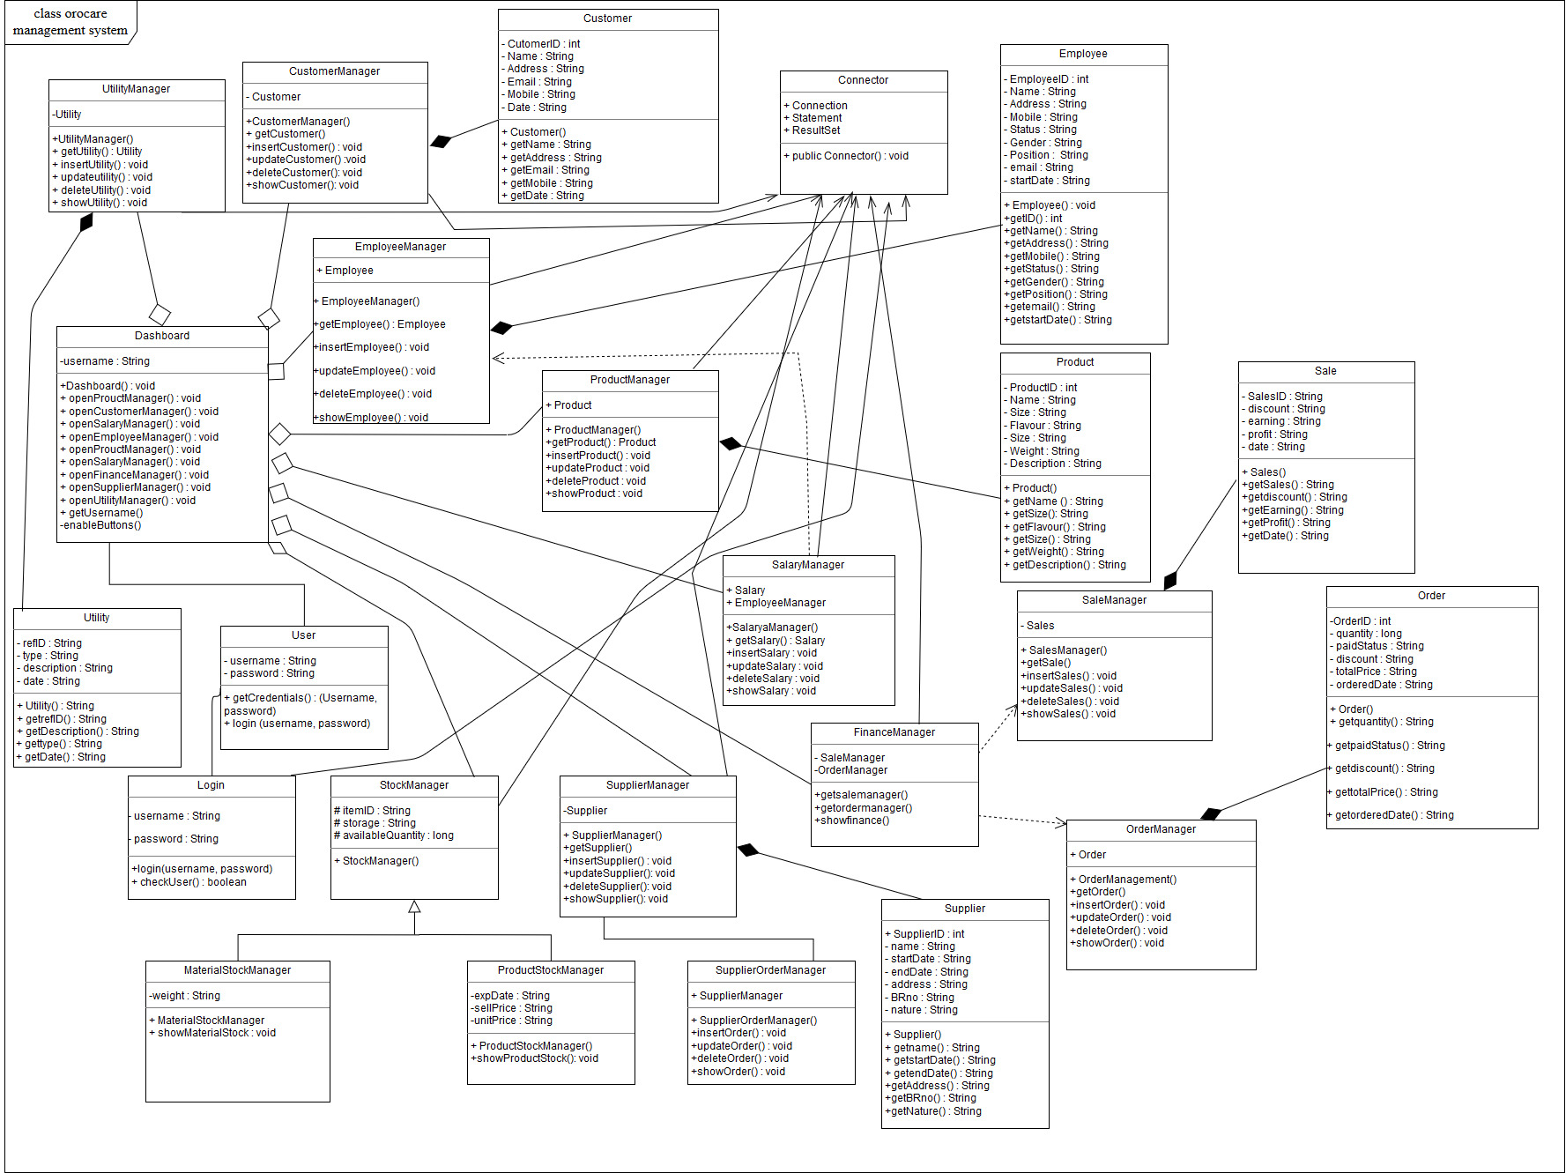

## Implementation

We have used Netbeans v8.2 as our main software for the implementation of the codes.The language used for developing the system is java, and for the database we have used sql,Mysql technologies.

The system is developed as standalone system which is supposed to deployed on client’s computer.Since the admin cannot handle all the management systems concurrently he can give access to employees as he desire.

All the users in the system deals with the system via the User Interface which is designed using Java Frames, and all the core modules of the system are connected to the database.

**Major Modules in Detail**

**Order Management**

This function is used to manage order details.Orcare employee’s faced many issues when managing customer orders like orders without enough stock,slow processing of orders,incorrect values etc.With this automated order management system orders can be easily managed.It is more convenient,reliable and less error prone.

The user is able to insert,update and delete orders.In addition the orders are divided into types as internal and external orders.Internal orders are orders that are being confirmed at the time of ordering itself.External orders can be confirmed later.Validation is used to check stock availability and incorrect values.

**Employee Salary Management**

Orocare toothpaste company has faced difficulties in handling salary details of employees. This automated salary system helps to manage their employee salary details. Employee can print a salary report using this system and administrator can add, update, remove salary details. All the salary records of employees are been stored in the system database.

User can keep and manipulate the salary details of all employees by inserting records. First user has to select a valid employee by selecting an available NIC number. This employee should has registered and active. Then user has to input allowance, leaves, deductions, EPF rate, ETF rate, net salary and month. Then user should press “Calculate Salary” button. Then EPF, ETF and total salary are generated automatically by the system. When user presses “Add” button details are added to the system with added date if details are valid and if all fields are filled. If data is invalid / fields are empty / salary calculation was not done, system displays proper error messages.

User can also update salary details. User has to select a valid employee salary detail by selecting a row of salary table. Then user can update relevant details. Then user should press “Calculate Salary” button to calculate updated total salary. When user presses “Update” button details are updated in the system if details are valid and if all fields are filled. If data is invalid / fields are empty / salary calculation was not done, system displays proper error messages.

User can also remove salary details by selecting a row and clicking “Remove” button. Then details are removed. Employee salary details are removed also when inactive an employee. When presses “Clear” button data which was entered are cleared. User can also search and print salary reports using this system.

## Testing

We have tested the fully integrated system by performing 2 different executions per each function and we have recorded the test results in an organized tabular format.

The results gathered for each function are as follows -

**Order Management**

|  |  |  |  |  |  |
| --- | --- | --- | --- | --- | --- |
| Test ID’s | Test inputs | Expected output | Actual output | Result(pass/fail) | Description |
| t1 | 1.Type - Internal  2.Customer id - 1  3.Customer name - Cargills  3.Quantity - 10.0  4.Discount - 50.0  5.Total - 2950.0  6.Product ID - 5  7.Location - Kottawa  8.Date - 08/06/2018  9.click automatically enabled “add” button. | 1.“Record added successfully” message  2.“Sales successfully updated” message  3.“Stock updated successfully” message | “Record added successfully” message  “Sales successfully updated “message  “Stock updated successfully” message | PASS | Inserting an order to the database. |
| t2 | 1.Select type- External and status - pending record from the order table.  2.Click automatically enabled “confirm order” button. | 1.”Order successfully confirmed message”  2.”Stock successfully updated” message  3.Status changes to confirmed. | 1.”Order successfully confirmed message”  2.”Stock successfully updated” message  3.Status changed to confirmed. | PASS | Confirming an “external” pending order. |

**Employee Salary Management**

|  |  |  |  |  |  |
| --- | --- | --- | --- | --- | --- |
| **Project ID :** ITP-2018-MLB-G1-08 | | | | | |
| **Project Title :** Management System for Orocare Toothpaste Company | | | | | |
| **Testing Function :** Add Employee Salary Details | | | | | |
| **Test case ID :** OC – ES01 | | | | **Test designed by :-**  **Reg No :** IT17024464  **Name :** Perera D.J.R | |
| **Test priority (High/Medium/Low) :** High | | | | | |
| **Test Description :**  The tester has to login to the main system, login to the Salary system, input relevant valid details, calculate total salary and add details to the system | | | | | |
| **Preconditions (If there are any) :**   * User should have logged in to the main system and logged in to the Salary system | | | | | |
| **Dependencies (If there are any) :** | | | | | |
| **Test steps :**   1. Select a valid employee by selecting an available NIC number 2. Input allowance 3. Input leaves 4. Input deductions 5. Input EPF rate 6. Input ETF rate 7. Input net salary 8. Select a month 9. Press “Calculate Salary” button and then EPF, ETF and Calculated Salary will be auto generated 10. Press “Add” button to add details to the system | | | | | |
| **Pass – condition :**   * Employee NIC number should be valid which should be already in Employee table * Allowance, leaves, deductions, EPF rate, ETF rate, net salary should be valid and can be in double data type * Month should be selected * All the fields should be filled * If all fields are filled and validated, details will be added to the system | | | | | |
| **Test ID** | **Test Inputs** | **Expected Output** | **Actual Output** | **Result (Pass/Fail)** | **Description** |
| **OC - AS01** | Employee:951245687V  Allowance: 7000.00  Leaves: 3  Deductions: 500.00  EPF Rate: 3.5  ETF Rate: 4.0  Net Salary: 30000.00  Month: January | EPF: 1050.00  ETF: 1200.00  Calculated Salary:  35450.00  Display successful message and add details to the system | Same as the expected output | Pass | Details will be added since all the fields are filled and valid |
| **OC - AS02** | Employee:975031306V  Allowance: 5000.00  Leaves: 4  Deductions: 600.00  EPF Rate: 4.5  ETF Rate: 3.2  Net Salary: hello  Month: March | Display error message “NetSal Field is Invalid !” | Same as the expected output | Pass | Details will not be added as long as NetSal field is invalid or empty |
| **OC - AS03** | Employee:966260050V  Allowance: 4000.00  Leaves: 2  Deductions:  EPF Rate: 3.4  ETF Rate: 4.2  Net Salary: 35000.00  Month: September | Display error message “Deductions Field Empty !” | Same as the expected output | Pass | Details will not be added as long as Deductions field is invalid or empty |

|  |  |  |  |  |  |
| --- | --- | --- | --- | --- | --- |
| **Project ID :** ITP-2018-MLB-G1-08 | | | | | |
| **Project Title :** Management System for Orocare Toothpaste Company | | | | | |
| **Testing Function :** Update Employee Salary Details | | | | | |
| **Test case ID :** OC – ES02 | | | | **Test designed by :-**  **Reg No :** IT17024464  **Name :** Perera D.J.R | |
| **Test priority (High/Medium/Low) :** Medium | | | | | |
| **Test Description :**  The tester has to login to the main system, login to the Salary system, update relevant valid details, calculate total salary and update salary details of the system | | | | | |
| **Preconditions (If there are any) :**   * User should have logged in to the main system and logged in to the Salary system | | | | | |
| **Dependencies (If there are any) :** | | | | | |
| **Test steps :**   1. Select a valid employee salary detail by selecting a row of salary table 2. Update relevant details 3. Press “Calculate Salary” button and then EPF, ETF and Calculated Salary will be auto generated 4. Press “Update” button to update details in the system | | | | | |
| **Pass – condition :**   * Employee NIC number should be valid which should be already in Employee table * Allowance, leaves, deductions, EPF rate, ETF rate, net salary should be valid and can be in double data type * Month should be selected * All the fields should be filled * If all fields are filled and validated, details will be updated in the system | | | | | |
| **Test ID** | **Test Inputs** | **Expected Output** | **Actual Output** | **Result (Pass/Fail)** | **Description** |
| **OC - US01** | Employee:951245687V  Allowance: 7000.00  Leaves: 4  Deductions: 1500.00  EPF Rate: 3.5  ETF Rate: 4.0  Net Salary: 30000.00  Month: February | EPF: 1050.00  ETF: 1200.00  Calculated Salary:  34450.00  Display successful message and update details in the system | Same as the expected output | Pass | Details will be updated since all the fields are filled and valid |
| **OC - US02** | Employee:975031306V  Allowance:  Leaves: 4  Deductions: 600.00  EPF Rate: 4.5  ETF Rate: 3.2  Net Salary: 30000.00  Month: March | Display error message “Allowance Field Empty !” | Same as the expected output | Pass | Details will not be updated as long as Allowance field is invalid or empty |
| **OC - US03** | Employee:966260050V  Allowance: 4000.00  Leaves: AB  Deductions: 1200.00  EPF Rate: 3.4  ETF Rate: 4.2  Net Salary: 35000.00  Month: July | Display error message “Leaves Field is Invalid !” | Same as the expected output | Pass | Details will not be updated as long as Leaves field is invalid or empty |

**Employee Management**

|  |  |  |
| --- | --- | --- |
| **Project ID :** ITP-2018-MLB-G1-08 | | |
| **Project title:** Management System for Orocare Toothpaste Company. | | |
| **Testing Function:** Add employee details. | | |
| **Test case ID :** OC – E001 | **Test designed by:** | |
| **Reg. No :** | IT16037816 |
| **Name :** | Weerasooriya M.N.H |
| **Test priority (High/Medium/Low):** High | | |
| **Test Description:**  The tester has to login to the main system, through that login to the Employee Management System & input the relevant valid details to the fields.  After that those details will be added to the system respectively. | | |
| **Preconditions (if there are any):**  User should have logged in to the main system & login to the Employee Management System. | | |
| **Dependencies (if there are any): -** | | |
| **Test steps:**   1. Input first name. 2. Input middle name. 3. Input last name. 4. Select the gender. 5. Input the address. 6. Select the date of birth. 7. Input the mobile number. 8. Input the position. 9. Input the NIC. 10. Input the email address. 11. Select the user privileges. 12. Press “Add” button & details will be added to the system. 13. After that select that row & press “Activate User” button,   only then the employee status will be changed into active. | | |
| **Pass-condition:**   1. Employee first, middle & last names should be inserted properly according to the String data type. 2. Gender & privileges should be selected. 3. Insert the valid mobile number, NIC & email address. 4. The position also should be inserted & all the other fields should be filled. 5. If all the fields are filled & validated only, the details will be added to the system. | | |

|  |  |  |  |  |  |
| --- | --- | --- | --- | --- | --- |
| **Test ID** | **Test**  **Inputs** | **Expected Output** | **Actual**  **Output** | **Result**  **(Pass/Fail)** | **Description** |
| OC – EM01 | 1. First Name : Nimali 2. Middle Name : Hasanthika 3. Last Name : Weerasooriya 4. Gender : Female 5. Address : 500/76, Aggona, Koswatta. 6. Date of Birth : 05.05.1986 7. Mobile : 0761597456 8. Position : CEO 9. NIC : 865248753V 10. Email : nimhasa@gmail.com 11. User Privileges : Emp, Prod | Display “Activate Successfully” message & add the details to the system. | Same as the expected output. | Pass | Since all the fields are filled, the details will be added to the system respectively. |
| OC – EM02 | 1. First Name : Asanga 2. Middle Name : Dinusha 3. Last Name : Gunawardena 4. Gender : Male 5. Address : 38/A, Sandunpura, Panadura. 6. Date of Birth : 07.12.1992 7. Mobile : 0713449578 8. Position : Manager 9. NIC : 92456185V 10. Email : asanga@gmail.com 11. User Privileges : Emp, Sales | Error message will display  as “Invalid NIC” | Same as the expected output. | Pass | Since the error message is display in the form, the details will not be added to the system. |
| OC – EM03 | 1. First Name : Jayani 2. Middle Name : Rukshila 3. Last Name : Perera 4. Gender : Female 5. Address : 85/B,   1st lane, Nugegoda.   1. Date of Birth : 24.03.1995 2. Mobile : 0724569S10 3. Position : Secretary 4. NIC : 958753159V 5. Email : jayeruk@gmail.com 6. User Privileges : Emp, Cust | Error message will display  as “Invalid mobile.”  (Entered String into the mobile number) | Same as the expected output. | Pass | Since the invalid mobile number is display, the details will not be added to the system. |

|  |  |  |
| --- | --- | --- |
| **Project ID :** ITP-2018-MLB-G1-08 | | |
| **Project title:** Management System for Orocare Toothpaste Company. | | |
| **Testing Function:** Update employeedetails. | | |
| **Test case ID :** OC – E002 | **Test designed by:** | |
| **Reg. No :** | IT16037816 |
| **Name :** | Weerasooriya M.N.H |
| **Test priority (High/Medium/Low):** Medium | | |
| **Test Description:**  The tester has to login to the main system, through that login to the Employee Management System, select the relevant fields & insert the updated details.  After that those details will be updated in the system respectively. | | |
| **Preconditions (if there are any):**  User should have logged in to the main system & login to the Employee Management System. | | |
| **Dependencies (if there are any): -** | | |
| **Test steps:**   1. Select the relevant row to update. 2. Select specific fields which are needed to update & insert updated details. 3. Press “Update” button & updated details will be added to the system. | | |
| **Pass-condition:**   1. Employee first, middle & last names should be inserted properly according to the String data type. 2. Gender & privileges should be selected. 3. Insert the valid mobile number, NIC & email address. 4. The position also should be inserted. 5. All the other fields should be filled. 6. If all the fields are filled & validated only, the details will be added to the system. | | |

|  |  |  |  |  |  |
| --- | --- | --- | --- | --- | --- |
| **Test ID** | **Test**  **Inputs** | **Expected Output** | **Actual**  **Output** | **Result**  **(Pass/Fail)** | **Comments** |
| OC – EM01 | 1. First Name : Nimali 2. Middle Name : Hasanthika 3. Last Name : Weerasooriya 4. Gender : Female 5. Address : 500/76, Aggona, Koswatta. 6. Date of Birth : 05.05.1986 7. Mobile : 0712589514 8. Position : CEO 9. NIC : 865248753V 10. Email : nimhasa@gmail.com 11. User Privileges : Emp, Stock | Display “Record updated Successfully” message & update the details to the system. | Same as the expected output. | Pass | Since all the relevant fields are filled, the details will be updated to the system respectively. |
| OC – EM02 | 1. First Name : Dinul 2. Middle Name : Tharaka 3. Last Name : Jayasinghe 4. Gender : Female 5. Address : 72/A,   Sandun Road, Ambalangoda.   1. Date of Birth : 14.09.1992 2. Mobile : 0715374895 3. Position : Manager 4. NIC : 921852456V 5. Email : dinult@gmail.com 6. User Privileges : Emp, Sales | Error message will display  as “Your gender should be Male” | Same as the expected output. | Pass | Since the error message is display in the form, the details will not be updated to the system. |
| OC – EM03 | 1. First Name : Jayani 2. Middle Name : Rukshila 3. Last Name : Perera 4. Gender : Female 5. Address : 85/B,   1st lane, Nugegoda.   1. Date of Birth : 24.03.1995 2. Mobile : 0724569S10 3. Position : Secretary 4. NIC : 958753159V 5. Email : jayeruk@gmail.com 6. User Privileges : Emp, Cust | Error message will display  as “Employee already activated” | Same as the expected output. | Pass | Since the employee already registered with the same details, the system will not be update. |

**Stock Management**

|  |  |  |  |  |  |
| --- | --- | --- | --- | --- | --- |
| Test ID’s | Test inputs | Expected output | Actual output | Result(pass/fail) | Description |
| t1 | 1. Product ID - 1  2. Product Name – Mint Flavor  3.Location - Gampaha  3.Quantity - 100.0  4.Unit Price - 135.0  5.Sale Price – 150.0  6.Manufact Date – 2018.07.12  8. Expiry Date – 2021.07.19 | 1.“Stock Product added successfully”  message  2.“Stock Product updated successfully”  message  3.“Stock Deleted successfully” message | “Stock Product added successfully”  message  “Stock Product updated successfully”  message  “Stock Deleted successfully” message | PASS | Inserting a Stock Item to  DB. |
| t2 | 1. Product ID - 2  2. Product Name – Regular  3.Location - Rathmalana  3.Quantity - 15.0  4.Unit Price - 135.0  5.Sale Price – 150.0  6.Manufact Date – 2018.07.12  8. Expiry Date – 2021.07.19 | 1.”Stock for Product ID : 2 at location – Rathmalana is currently getting low”  Message. | 1.”Stock for Product ID : 2 at location – Rathmalana is currently getting low”  Message. | PASS | Confirming an “external” pending order. |

# Evaluation

## Assessment of the Project results

The system was given to the employees of the client’s company to carry out the testing. The testings were recorded and the data was analyzed .

## Lessons Learned

Learned how to work as a team

Gained further knowledge about java language

Learned how to make a stand-alone application using Netbeans.

Learned how to interact with a customer to gather information such as requirements.

## Future Work

* SMS notifications can be implemented in this system.
* Email notifications can be implemented in this system.
* The finance management can be further improved by adding bar graphs.
* Attendance management can be implemented to the employee management system to record leaves, ot hours.

# Conclusion

The main purpose of developing this system was to automate company’s work. Advanced management systems like attendance management system followed by fingerprint scanner can be implemented to this system.

One of the main weakness of this system is that the system is not optimized hence as the database gradually expands day by day the system may require maintenance, as well as optimizations.

# References

* Stack Overflow. (2018). *Stack Overflow - Where Developers Learn, Share, & Build Careers*. [online] Available at: http://stackoverflow.com/ [Accessed 9 Oct. 2018].
* Google.com. (2018). *Google*. [online] Available at: http://google.com/ [Accessed 9 Oct. 2018].